# Simple Weather Application

## What is the simple Weather Application:

Simple Weather Application is a C# based app designed and implemented to call a RESTful API from open weather website <http://openweathermap.org/api>. This application also used .NET libraries such as System.Net.Http and Newtonsoft.Json.

Algorithm in this application is pretty straight forward. It will create a client and call the API host and request for the weather data requested by user for the desired city. After receiving the current data, it uses Newtonsoft library to deserialize the incoming JSON file and print and display the following for each city:

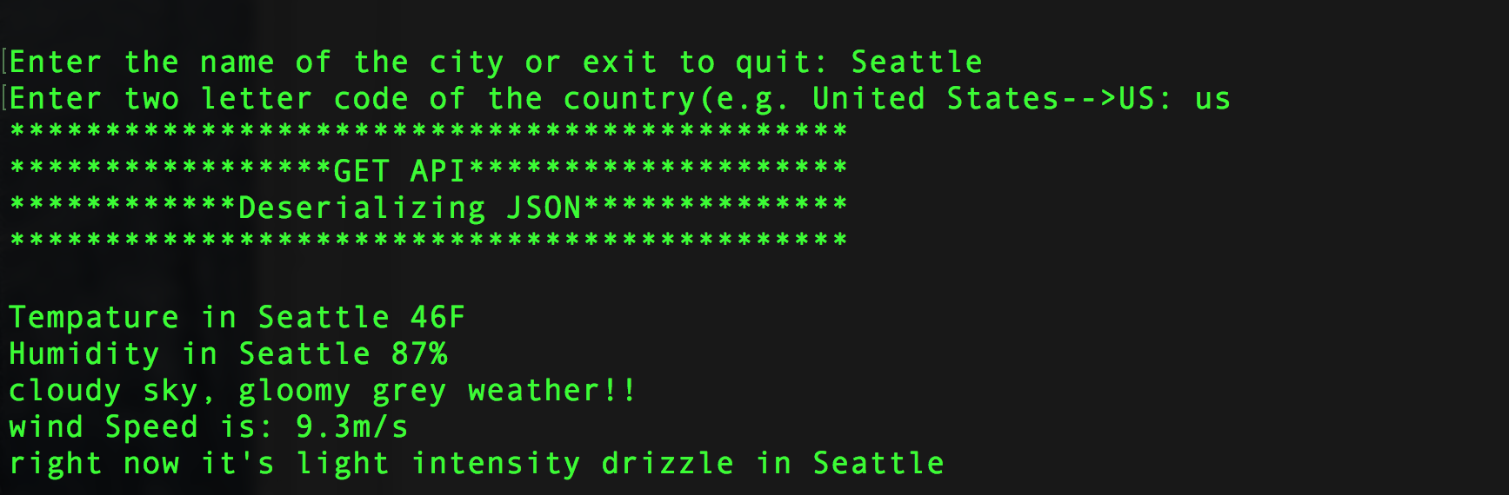

## How to Use The App

*Windows Users:

All you have to do is to unzip the zipped file in one folder and run the WeatherApp.exe file.

*macOS Users:

- you can download MONO from: http://www.mono-project.com/

- open the terminal and go to the directory which you have unzipped the file in

- type in the following:

$ mono WeatherApp.exe

After you successfully opened the application it will ask you to input the name of city and ID of the country (country's ID is a two Letter unique word, e.g. United States: US Netherland: NL, Germany: DE, France: Fr, Iran: Ir, Afghanistan: Af and etc.)

In order to exit the application, you can simply type exit or quit or q any time at any of the provided prompts.